Mahmoud Ezat, Matt Provini

*Team 6 - The Go Getters*

**Requirements Document Draft**

# Introduction(Mahmoud)

The purpose of this requirements document is to detail and comprehensively portray the mechanics of use behind our app. This document will outline use cases, requirements for the system, and will outline system sequence through charts. Through all the detail collected in this document, the basis for the entire project will be established. This document will also act as a useful resource for the many different teams that will be involved in the process.

# Description Model (Matt)

1. Initial Requirements

Getter is a mobile application, it is available on all Apple and Android devices. Getter must have an internet connection to work properly, as well as have access to your location to find restaurants near you. Getter must also be given permission to open a 3rd party direction app of your choice to give you directions to your desired location.

1. Processes
2. Login Screen

In order to begin using Getter you must be signed into an account, if you have an account you may enter your credentials as provided, if you need to create an account you may select so and begin the process. To create an account you must provide an appropriate username, your email address, and a password from 6-12 characters. Once you’ve provided your information you can click continue and a confirmation email will be sent to verify your creation of the account. Only one account may be created per email. If you are signing in and forgot your username/password you may select so and an email will be sent to retrieve your account back.

1. Welcome Screen

On the welcome screen a list of filters will be provided in order to help us better understand what you are looking for. If you have not already given permission to use your location you will be prompted to do so, if denied, the app will prompt the user to go to settings and turn it on or else the app cannot function properly. If the user is searching for something more particular a search bar is provided at the top of screen and will filter results via keywords. The recommended filters will be shown based on prior interaction with the app or time of day. For instance, if it is past 5:00 PM, mainly results will be shown based on popular dinner locations nearby. Once a filter or search has been made, it will bring you to the selection screen.

1. Selection Screen

On the selection screen, results will be displayed based on our algorithm with a variable of your filter(s) given. Our top three choices will be shown and if the user would like to see more, an option is given to look deeper. If the user is not given results they are pleased with, they can add an additional filter on top of the one applied, or change the filter to change results. For example, the user may have selected a dinner filter such as type of food, or price range and was shown sit down restaurants when they are in a rush, so they can select a “Fast Food” filter to adjust results. Once a result has been selected it will then bring you to the information screen.

1. Information Screen

On the information screen, the selection made by the user will be displayed in the most detail to the user. This screen will include information such as the distance, ratings, description of the restaurant, address, and phone number, as well as an image. The distance will be provided based on the location of the user displaying in mile and time distance. In Getter’s early stages our ratings will be provided via Google until a reputation is built around the application having enough of its own ratings. The description, address, and phone number will also be provided this way in its early stages. The user may also select a button on the information screen to favorite a restaurant for quick access in the future. Once the user is content with their selection they may select the option to direct the user to an ordering portal that is 3rd party.

1. Feedback Screen

The feedback screen will most likely be displayed once the user returns to the app after getting to their location. In order to persuade the user to return to the app for their rating a push notification will be given to the user encouraging them to leave feedback. Once returned to the app a screen will be displayed allowing the user to leave a rating via a 5 star system, followed by an optional text box explaining why. After feedback is left, the user will be returned to the Getter home screen.

# Class Diagram (Matt)

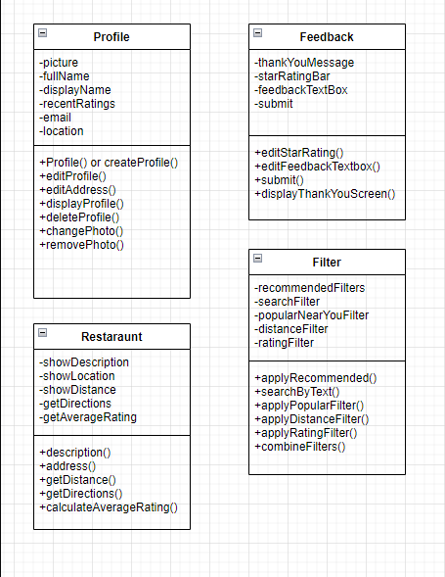

# Use Case Diagram(Mahmoud)

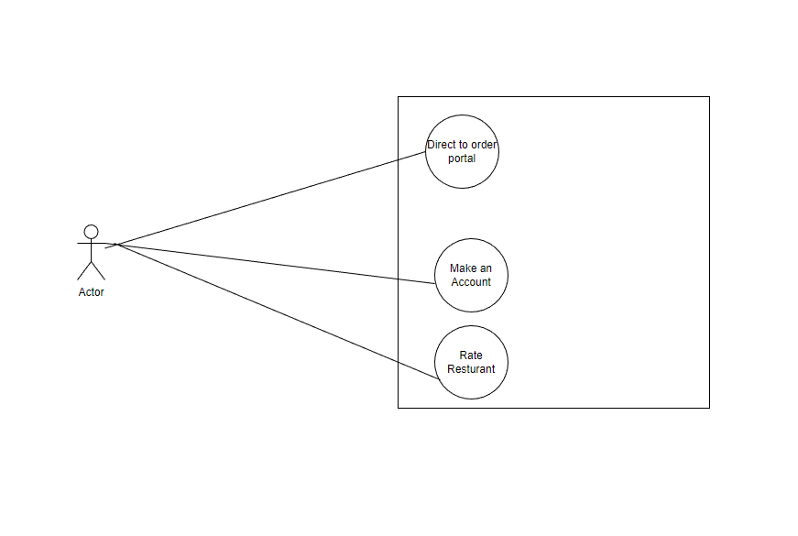

# Use Case Scenarios(Mahmoud)

Create a full description Use Case Scenario (detailed descriptions) for each use case of the system. This intermediate scenario should include an enumerated list of steps involved in the activity as well as any exception conditions.

|  |  |  |  |  |  |
| --- | --- | --- | --- | --- | --- |
| Use Case Title | Make account |  |  |  |  |
| Primary Actor | Member |  |  |  |  |
| Level | Full Description |  |  |  |  |
| Stakeholders: | Getter User Database |  |  |  |  |
| Precondition: | Access to the application on mobile device |  |  |  |  |
| Postcondition | Account made to access Getter app |  |  |  |  |
| Trigger: | Potential user wants to join Getter |  |  |  |  |
| Main Success Scenario: | actor | System |  |  |  |
| 1 | Download app | App is configured for the specific device in question |  |  |  |
| 2 | Open app and click on join | System shows account creation dialog |  |  |  |
| 3 | Create credentials for Getter | Text is placed in text return dialog boxes |  |  |  |
| 4 | Complete captcha | User is confirmed to be human |  |  |  |
| 5 | Click create account | Account is logged in database |  |  |  |
|  | Confirm email sent by clicking on emailed link | Account is marked as verified |  |  |  |
|  | Renter to log in | System shows login dialog box |  |  |  |
|  |  |  |  |  |  |
|  |  |  |  |  |  |
| Exceptions | If user wants to back out, click cancel |  |  |  |  |
|  | If user fails captcha, process is restarted |  |  |  |  |

|  |  |  |  |  |  |  |
| --- | --- | --- | --- | --- | --- | --- |
| Use Case Title | Rate restaurant |  |  |  |  |  |
| Primary Actor | Member |  |  |  |  |  |
| Level | Full description |  |  |  |  |  |
| Stakeholders: | member and restaurant |  |  |  |  |  |
| Precondition: | member must have placed an order from said restaurant |  |  |  |  |  |
| Postcondition | member places an order publicly for said restaurant |  |  |  |  |  |
| Trigger: | member would like to share their experience on the experience |  |  |  |  |  |
| Main Success Scenario: |  |  |  |  |  |  |
| 1 | member goes to past orders and clicks review for the specific order | member is brought to give review dialog page |  |  |  |  |
| 2 | member enters comments in box | system captures text entered and saves in text return box |  |  |  |  |
| 3 | member clicks desired amount of stars out of 5 | system demarcates amount of stars dictated by user |  |  |  |  |
| 4 | member clicks review rating | review summary of rating is shown to user |  |  |  |  |
| 5 | member clicks post review | system posts public review to restaurant page |  |  |  |  |
|  |  |  |  |  |  |  |
|  |  |  |  |  |  |  |
|  |  |  |  |  |  |  |
|  |  |  |  |  |  |  |
| Exceptions | rating comments are blocked for explicit phrases |  |  |  |  |  |
|  | member backs out before posting |  |  |  |  |  |

|  |  |  |  |  |
| --- | --- | --- | --- | --- |
| Use Case Title | order |  |  |  |
| Primary Actor | Member |  |  |  |
| Level | Full description |  |  |  |
| Stakeholders: | member and restaurant |  |  |  |
| Precondition: | member must have valid payment method and account |  |  |  |
| Postcondition | member is given an order confirmation |  |  |  |
| Trigger: | member wants to order food |  |  |  |
| Main Success Scenario: |  |  |  |  |
| 1 | Member adds desired items to cart and clicks checkout | app logs items to user's cart and brings checkout page to front |  |  |
| 2 | member adds valid address | system verifies address and saves as delivery address |  |  |
| 3 | member adds valid payment method | system verifies payment method and stores for order placement |  |  |
| 4 | member clicks review order | summary of all information entered is displayed for review |  |  |
| 5 | member hits place order | system contacts restaurant with order and places order in user's changelog |  |  |
|  |  |  |  |  |
|  |  |  |  |  |
|  |  |  |  |  |
|  |  |  |  |  |
| Exceptions | payment method is not valid |  |  |  |
|  | address is not valid |  |  |  |
|  | restaurant is closed unexpectedly |  |  |  |

# System Sequence Charts(Matt)

